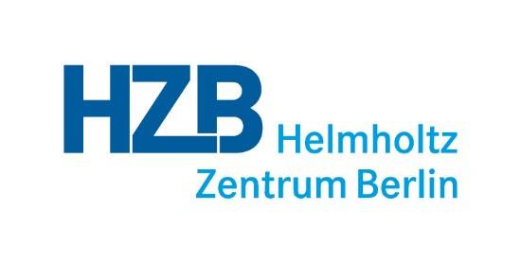

HZB guidelines for doctoral researchers and advisors

- Appendix B -

First progress report

- Progress report

General information
Name of doctoral researcher:
Date of progress report:
Date of first progress meeting:
Next planned progress meeting:
Title of doctoral thesis (or working title):
Graduate program, if applicable

Project proposal
(Description of i) aim and accordingly scientific and societal relevance of the doctoral project, ii) scientific challenge and hypothesis to be tested etc.)

Time and work plan
(Listing of planned milestones/main results, that will test the hypothesis, as well as their implementation (work steps, methods etc.). The time and work plan has to be set up for the entire doctorate and can be divided in several milestones/tasks per year. If applicable at that early point of time, current status of the milestone/task has to be noted)
Year | Task No. | Milestone/expected result | Work step/method to reach milestone | Current status (what was achieved / what still needs to be done)
(Please extend the table, if required)

Qualification plan
(Listing of all planned subject-specific and interdisciplinary qualification measures, activities etc.. Categories marked in green are expected to be performed prior to submission of the dissertation by HZB. Categories marked in blue are compulsory)
Category | Name | Planned on | Actual date
Publications
Peer-review publication (first author)
Peer-review publication (co-author)
Book chapter
Conference proceedings
Presentation of results
Talk on international conference
Poster presentation on international conference
Scientific presentation (HZB internal)
Subject-specific qualifications and programs
Training on „Good Scientific Practice“
HZB-internal institute- and department seminars
Participation at HZB Doctoral Researchers Retreat
Lectures
Summer-/winter schools
Contributions to teaching tasks
Contributions in planning of research projects/acquisition of funding
Attendance of doctoral researchers seminar
Exchange programs/stays abroad
Supervision of bachelor or master theses
Interdisciplinary qualification and programs
Transferable skills training
Measures on career development and planning (field trips, internships etc.)
Language course
Contributions to HZB campus life
Contributions to the „Schülerlabor“
Guided tours for pupils or guest groups
Public outreach (contributions to events like „Lange Nacht der Wissenschaft”, “Girls‘ Day” etc.)
Contributions to the scientific community (within and beyond HZB)
Contributions to networks (HZB doctoral researcher representation, HeJus etc.)
Contributions to maintenance of laboratory equipment and scientific facilities
Being a buddy for new HZB doctoral researchers
Organisation of conferences

Problems / challenges encountered
(Short description of technical problems and challenges, e.g. regarding technology, equipment, resources etc.)

Risks and potential impact on doctoral thesis / required measures
(Short description of feasibility of doctorate. Is it at risk, if yes, by what? Short descriptions of potential risks and required measures, descriptions of alternatives if planned etc.)

Miscellaneous

Comment of supervision committee
(Short assessment on overall status of the progress and the performance of the doctoral researcher)
Assessment of progress: (please mark accordingly)
Very good
Good
Satisfactory
Non-satisfactory
Assessment of quality of work*:
Very good
Good
Satisfactory
Non-satisfactory
Assessment of quality of supervision:
Very good
Good
Satisfactory
Non-satisfactory
Continuation of doctorate:
Recommended
Recommended (under the conditions listed below)
Not recommended
*Refers to working manner, compliance with rules of good
scientific practice etc.
Conditions for continuation of doctorate, further comments:

Comment of doctoral researcher
(Short assessment on overall status of the progress, quality of supervision, situation at HZB and within working group)
Assessment of progress: (please mark accordingly)
Very good
Good
Satisfactory
Non-satisfactory
Assessment of quality of work*
Very good
Good
Satisfactory
Non-satisfactory
Assessment of quality of supervision
Very good
Good
Satisfactory
Non-satisfactory
Continuation of doctorate
Wanted
Wanted (under the conditions listed below)
Not wanted
*Refers to working manner, compliance with rules of good
scientific practice etc.
Conditions for continuation of doctorate, further comments:

Optional: Comment of division spokesperson
(If applicable, short comment of division spokesperson or division coordinator)

Signatures:
All parties agree on the progress report and, where applicable, the changes or adjustments made.
Date and signature
Doctoral researcher
Main advisor
Daily advisor
Second daily advisor
Backup main advisor
Division coordinator
Further members

