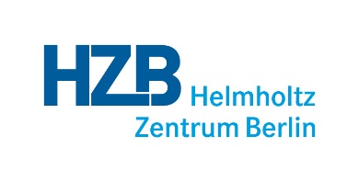
Transcript of Records

This is to certify that

Name

born in

has successfully met the requirements for doctoral researchers at the Helmholtz-Zentrum Berlin (HZB) pursuant to the HZB guidelines for doctoral researchers. The activities, trainings and contributions made, are listed below.

Research Project:

Department:

________________________________ __________________________________
Name of main advisor Prof. Dr. Bernd Rech
Main advisor Scientific director of the Helmholtz-Zentrum Berlin

Berlin, date

Activities, trainings and contributions made by: Name
Category | Contribution* | Place | Date
Publications:
Presentation of results:
Subject-specific qualification and programs:
Training on „Good Scientific Practice“
Interdisciplinary qualification and programs:
Contributions to HZB campus life:
Contributions to the scientific community (within and beyond HZB):
*Specifies the kind of contribution or activity, e.g. talk, poster presentation, workshop etc.

